Region and Domain

This dataset contains all medals awarded for all participating countries from 1896 up to 2020(1). This dataset was used to create this animated bar chart race:
https://www.youtube.com/watch?v=81ZJL07GL4s

Region = Worldwide
Domain = Sports and Athletics

Research Question

How have the %of Total Medals and %of Gold Medals won by the US changed over 1986 -2020 ?

Links

Data was scraped from Wikipedia pages containing the tables of medals.
The dataset was downloaded from Kaggle https://www.kaggle.com/datasets/ramontanoeiro/summer-olympic-medals-1986-2020/versions/1?resource=download

Image

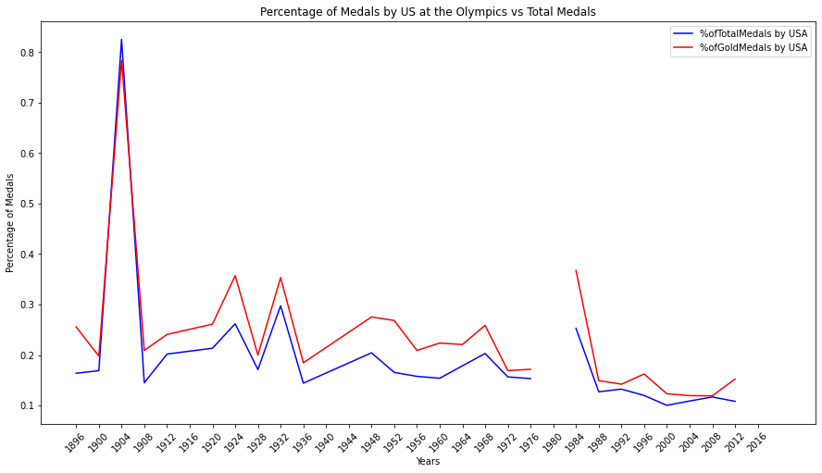

- Data reveals that USA was dominant at the Olympics at 1904 Olympics, having won almost 80% of total as well gold medals won
- 1924, 1932 & 1984 were also very good years, especially the percentage of gold medals won
- Starting 1988 there seems to have a downward trend in the % of medals, however the trend may be starting to reverse starting 2012 based on the uptick in the % of gold medals won

